Template – Financial Aid Verification
The template named “Template – 2018 2019 Independent Verification Form with DocuSign” is applicable to Anthology Student.

Purpose and Outcome
This template provides a form sequence and supporting workflow for a financial aid verification form. The template simplifies a significant portion of a complete student self-service financial aid verification process as detailed in the Financial Aid Verification Process README STEP 2 document.

Prerequisites
The template was built with Forms Builder using the applications listed below. The template is forward compatible with later versions of the listed applications.
Application | Compatibility Version
Forms Builder Designer and Renderer | Compatibility Matrix
Web Client for Anthology Student
Workflow Composer
Packages installed from Package Manager in Workflow Composer | Activities and Contracts (V2)  Contracts (V1)  Forms Builder Contracts  Note: Ensure that the Forms Builder Contracts package used in Workflow Composer is aligned with the version used in the Forms Builder. Additionally, confirm that both Activities and Contracts (V1) and Activities and Contracts (V2) packages in Workflow Composer match the versions used in the Student Web Client to avoid compatibility issues.  It depends on which product is being used, for example:  For CRM:  Activities And Contracts (CRM)  Forms Builder Contracts
Workflow Tracking Database | N/A
Staff STS | 3.3.x

Step 1: Download and Import the Template
- Download the template file to your environment (local drive or network location).
- Log into Forms Builder Designer.
- Click the Export/Import tile.
- Select the Import tab.
- Click Select exported file and navigate to the downloaded template file.
- Click Import.
Note: Import may fail if same files name is already available in environment or overwrite option.
- Export/Import

The following forms will be imported:

2018 2019 V1 Independent Verification Step 1

2018 2019 V1 Independent Verification Step 2

2018 2019 V1 Independent Verification Step 3

Default-Frame

2018 2019 V1 Independent Verification Step 4

Custom - Confirmation Standard No Auto Close

Step 2: In Form Designer…
- From the Forms slide out, select 2018 2019 V1 Independent Verification Step 1.
- Customize the form for your environment. Modify properties on current fields to make them required, etc., or add/remove fields on form. Make sure you edit the text in the Labels and HTML controls as applicable for your institution and the financial aid award year.
Note: In Form Designer, all checkbox controls are bound to one in/out workflow argument called myDictionary, which is an array. The workflow will have one argument instead of many for the Model bindings for every checkbox across all the forms. If you modify any checkbox controls, be careful to maintain a unique array index for each item across all forms in the sequence.
- Fields and Components
- Save the form.
- From the Forms slide out, select 2018 2019 V1 Independent Verification Step 2.
- Customize the form for your environment and save it.
- From the Forms slide out, select 2018 2019 V1 Independent Verification Step 3.
- Customize the form for your environment and save it.
- From the Forms slide out, select 2018 2019 V1 Independent Verification Step 4.
- Customize the form for your environment and save it.

Step 3: In Sequence Designer…
- Select 2018 2019 V1 Independent Verification Sequence.
The sequence contains the following forms:
- 2018 2019 V1 Independent Verification Step 1
- 2018 2019 V1 Independent Verification Step 2
- 2018 2019 V1 Independent Verification Step 3
- Default Frame (This form is required if DocuSign is used for electronic signatures.)
- 2018 2019 V1 Independent Verification Step 4
- Click Save As to create a copy of the sequence/workflow and customize the copy for your use. This way you can always refer to the original sequence/workflow you downloaded.
- Optional - Add a custom style (theme) associated with your campus.
- Themes
- Select your sequence in the Sequences pane.
- In the Properties Pane:
  - Ensure that the Authentication Product is Student.
- Select the End State Form named Custom-Confirmation Standard No Auto Close.
- Save the sequence.
- Open the associated sequence workflow.
Depending on your environment, to open Workflow Composer either click Open Workflow in Sequence Designer or launch of a local installation of Workflow Composer.
- Opening Workflows for Sequences

Step 4 In Workflow Composer…
- Locate the LookupReferenceItem activity in the first Form/State and verify that the Independent Verification Form is found in your environment.
The template assigns the following values to the activity. Modify the values as necessary for your environment:
      - Display Name: Find Document
      - Reference Item Type: Document Type
      - Reference Item: Verification for Independent
      - Reference Item Id: This is the Id of the document selected above and will auto populate.
- In the transition after the Default-Frame state, in the CreateDocument activity, verify that the Document Status is applicable for your environment.
Note that the status value is set in both branches of the If condition (“If document exists”). Where the value is already found (not created), the value is hard-coded.
Use a Lookup Reference Item activity to find the correct status value for your environment. Simply drag/drop the LookupReferenceItem activity into the workflow. Select the Type you are looking for (e.g., Document Status) and then select the Item you are looking for within that.
The document status for all documents in this process will be Ready for Review. The activity will return the hard-coded Id value (e.g., 13).
- LookupReferenceItem activity
- In the same transition after the Default-Frame, check and set the Task Type value appropriate for your environment.
Again, use a Lookup Reference Item activity to find the correct Task Type value for your environment.
- In the Final transition, check the CreateDocument activities for each document uploaded and verify the Document Type. If desired, you can specify the Document Type for all items as “Verification Document”.

Step 5: In Forms Renderer and Anthology Student…
Select your sequence and try it out! Go ahead and add the Verification for Independent Document to your student as “Requested Required”.
- Sequence List
- Find your Verification sequence and copy the URL to the clipboard.
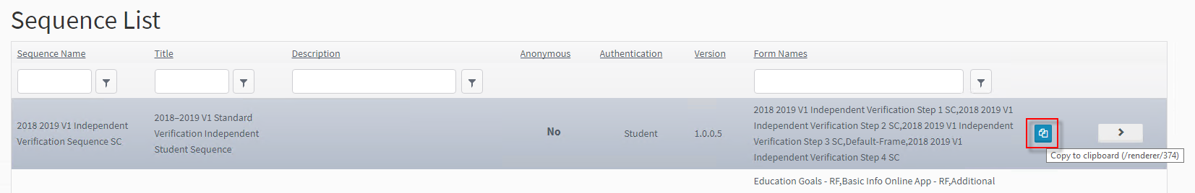
- In Anthology Student, verify the staff member was notified to complete the Verification Process.
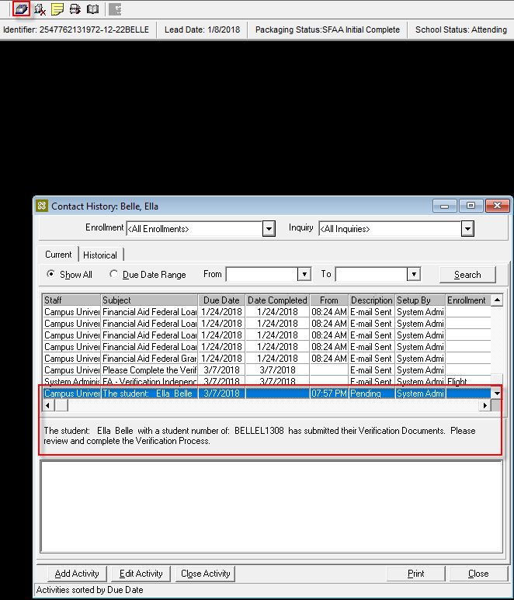
- In Anthology Student Desktop Client, navigate to View> Contact Manager > Activities and confirm that the Verification for Independent Document is “Ready for Review” and any additional Verification Documents have been added to the Document Center for the Student as “Ready to Review”.
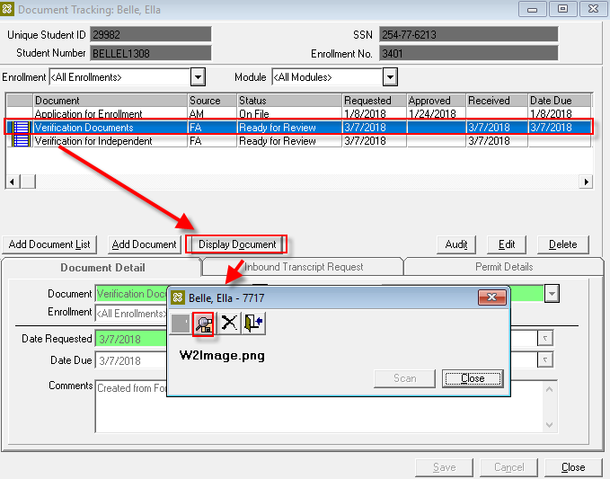
At this point the form only updates the Verification for Independent Document, adds the Verification Documents, and notifies a staff member.
The process to trigger the document to the student is as follows:
- The import of an ISIR will trigger the Verification for Independent document to be added to the document center for the student as Requested Required.
- The adding of the document triggers another workflow to send the link to the student.
- The student will click on the link and complete the form.
- The Verification for Independent document will have the PDF attached and status updated to Ready for Review, and any other Verification Documents uploaded will be added to the document center in the same status.
- The Staff member will be notified to complete the verification process for the student.
Test the sequence for a student who does not have a verification form on file and uploaded multiple verification documents. Also test the sequence for a student who already had a verification form on file.

Step 6: Lastly…
Once your updated sequence has been tested successfully, it is recommended that you disable the workflow for the original Template version.
- In Workflow Composer, in the Server section of the ribbon, click Open.
- Find the workflow named 2018 2019 V1 Independent Verification Sequence.
- Clear the Enabled check box and click Save.

Continue with Lesson 2: Create Workflows to Automate the Verification Process on page 108 of the attached document to complete the remaining steps of building and testing the FA verification process.

